# EXPERIMENT NO 04

Q1. Perform following queries on bank database:

CREATE TABLE BANK7(ACC_NO VARCHAR(10),BALANCE BIGINT,LOAN_AMOUNT BIGINT,BRANCH VARCHAR(20));

INSERT INTO BANK7 (ACC_NO,BALANCE,LOAN_AMOUNT,BRANCH)

VALUES

('A-57321', 70000 , 900000 ,'PERRYRIDGE'),

('A-89301', 700 , 0 ,'PERRYRIDGE'),

('A-457892', 198523 , 300000 , 'CAPITAL BANK'),

('A-784596', 1520 , 0,'LIVERPOOL'),

('A-702314', 45000 , 30000,'PERRYRIDGE'),

('A-15796', 250000 , 75000,'CAPITAL BANK'),

('A-33794', 759 , 8563,'MUMBAI'),

('A-157960', 799 , 0,'TORONTO'),

('A-012297', 800 , 0,'PERRYRIDGE'),

('A-874521', 87005 , 20000,'CAPITAL BANK'),

('A-507821', 60088 , 0,'LIVERPOOL'),

('A-897301', 900000 , 500000,'LOS ANGELAS'),

('A-864003', 70000 , 900000 ,'DAEGO'),

('A-64872',710,0,'CAPITAL BANK'),

('A-55500', 9000 ,0,'PERRYRIDGE'),

('A-270391', 70000, 0,'PERRYRIDGE');

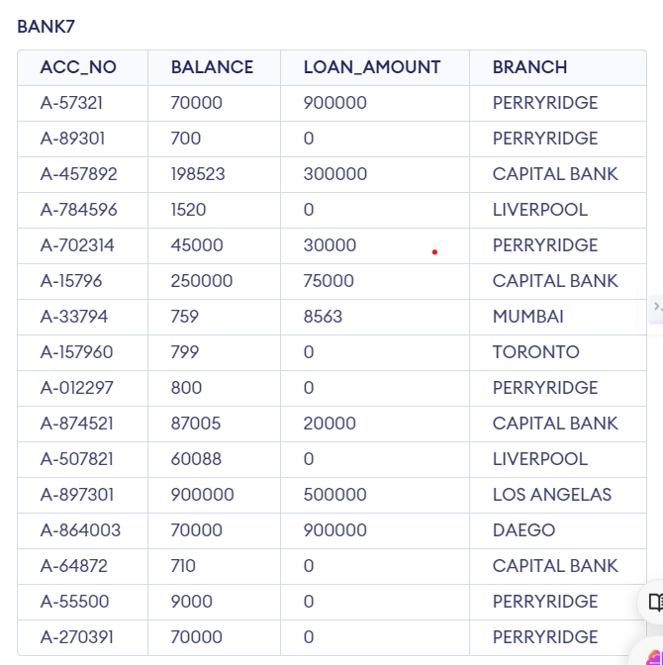

1. Find the average account balance at the Perryridge branch.

SELECT AVG(BALANCE) AS AVERAGE_BALANCE

FROM BANK7

WHERE BRANCH='PERRYRIDGE'

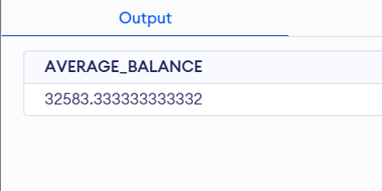

1. Find maximum amount of any loan in the bank

SELECT MAX(LOAN_AMOUNT) AS LOAN_MAX

FROM BANK;

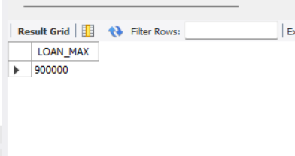

1. List Numbers of accounts with balances between 700 and 900

SELECT COUNT(ACC_NO)

FROM BANK

WHERE BALANCE BETWEEN 700 AND 900;

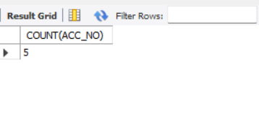

1. List total number of account holders in the ‘Capital Bank’ Branch

SELECT COUNT(ACC_NO)

FROM BANK

WHERE BRANCH='CAPITAL BANK';

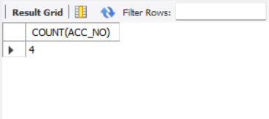

1. List total number of unique Customer city names

SELECT DISTINCT BRANCH

FROM BANK;

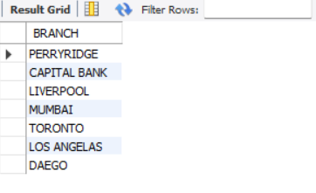

1. Find the number of branches that currently have loans.

SELECT DISTINCT BRANCH FROM BANK

WHERE LOAN_AMOUNT !=0;

